ISIGIDIMI SAMAXOSA, SEPTEMBER 1, 1872,
7

KWELE DIAMOND!.
Inxowa Yokugqibela yezazibiwe ngu Harding ifunyenwe, zati ezinye incwadi zatunyelwa kubaninizo.
U-Mr. Flannigan usand’ ukutenga isiqendu eesitatu somhlaba wokumba warola £1500.
Ukutengiswa Kwe Diamondi.—Uti ngoku eke wutengisa idiamoudi, kwixesha elisusela eku- tshoneni kwelanga kude kube sekupumeni kwalo adliwe £10.
Ababanjwa aba 12 basand’ ukubaleka etolon- gweni yase Klipdrift. Bate kanti bafumene intsi- njana bemba ngayo ituba lokupuma eludongeni. Mnye kupela obuye wabanjwa.
Ofunyenwe Efile—U-Captain Greatham wa- se Natal, obengunibi we diamondi ufunyenwe sele- file etenteni yake. Uzibulele ngokusuke agqitise akusela iyeza elitile ekutiwa yi laudanum.
Abembi Abantsundu—Kute ngenxa yokubiwa kangaka kwe diamondi ngabantsundu, bada ba- hlanganisana abembi abamhlope bakona bendza umteto wokuba kungabiko namnye umntu ontsu- ndu oyakuba nendawo yokumba eyeyake, bati nabo bebesebenazo, bahlale kuzo inyanga ibenye kube kupela. I-Governore ayivumanga ukuwam- kela lomteto kuba ubabandezela ngokugqitisileyo abantsundu.
Ukubulala—U-John Creed Harley no James Craig bafakwe etolongweni, ngetyala lokubulala. Kutiwa lomntu ufileyo baqale bambopa izandla nenyawo bambeta ngentsontelo, bazake kamva bamana bemsika ngesitshetshe wada wafa. Bate bakugqiba ukumbulala bayakuxelela U-Dr. Thorne bati ube nxilile, wabulawa kukuhamba esiwa nayi- nqele. Ityala labo lisayakutetwa.
Inkuni ziyenyuka kanye ngenani. Enye iflara ebisand’ ukutengwa idle £5 12s 6d.
Icesine libuye lakula kona, Kulendawo kutiwa yi New Rush amagqira amabini abenabantu aba 50 ababulawa lilo lodwa.
Ontsundu Otembekileyo—Ute umfo ontsu- ndu abati ngu July edlula kwimfumba etile yenku- nkuma wacola idiamondi wayisa kwi Mantyi yakona U-Mr. Giddy. Ute umnini walomhlaba icolwe kuwo akuza kuyibanga ku Mr. Giddy wavuma U-July ukuba ayinikwe lomfo, kuba yinto yake. Uteke umnini diamondi wamvuza U-July ngokokutembeka kwake ngeponti ezi £6.
Basebanindzi Abafuduka kwele Diamondi ukuya kwele Golide E-Transvaal Republic. Aku- kaqondakali kakuhle ukuba igolide yakona yoku- buyiselana ukusetyenzwa kwayo; kodwa oko kuya- kubehle kuqondakale, ukuba kuke kwaya abembi nokuba bangamawaka ambawa.
NATAL.
Umbona nama Zimba asikuko nokuba anqabile. Inxowa irolelwa isheleni ezi 21s.
Ikofu nonyaka ingati ayiyi kucuma njenganya- kenye. Kodwa ke noko amasimi anonyaka ma- kulu kunawanyakenye, kengoko akuyi kubako ndleko inkulu.
E-England kulingwa ukubolekwa iponti ezi £55,000, eziya kunceda ukwaka ozindlela nezinye izinto E-Natal.
I-Lieutenant-Governor yase Natal U-An- thony Musgrave ufike kona ngo 15 ka July, wam- kelwa ngovuyo olukulu ngabantu bakona. Kute
ngo 19 ka July, wafunga ngendlela abafungiswa ngayo abapete lomsebenzi pambi kokuba bawuqale.
KWELA MAZULU.
Kuvakala ukuba Amazulu ayafuduka kakulu aya kwela Maswazi. Isizatu sokuba Amazulu alishiya izwe lawo asisazi. Kubonakala ukuba Amaswazi aranela ukuti Amazulu lawo anxamele ukuwaqubula. Ngoku Amaswazi anxamele ukusitengisa kube Lungu isiqendu somhlaba wawo esingakwe la Mazulu. Ngokwenjenjalo afuna ukunqabisela abafuna ukuwapanga umhlaba.
EZASE LUSUTU.
Kwakute ngo February inxenye yenkosi zase Lusutu, namapakati zatumela isicelo kwi Gover- nore yale Koloni sokuti nabo Abesutu makubeko amadoda awabameleyo E-Parliamente. I-Governore yapendula ngo March yati ayingelunge lonto ngenxa yezizizatu—ukuqala, kungati ukuba bana- madoda awabameleyo elolizwe lawo lingalaulwa kwangalemiteto ikoyo apa kule Koloni, kanti aba- ntu bakona abakayilungeli. Kwindawo yesibini zingati indawo ezingamiweyo ngoku kona zivuleke kuma Ngesi atanda ukuya kuma kona. Kwindawo yesitatu, kungati kuke kwanjalo kungavuleka ituba lokuba kutengiswe utywala babelungu, bu- ngabi nakutintelwa njengokuba kunjalo ngoku. Elolizwe ngoku lilaulwa zimantyi zama Ngesi. Imi- teto yakona ibalungele kanye abo bantu kwesisimo bakuso, akubonakalike ukuba ingeyiguqulwa. Ba- yakauleza kanye ukuhambela pambili. Bati no- kuyibatala irafu bakwenze oko ngoxolo kuba ba- yazi ukuba ngoku bapetwe kakuhle ngapezu koko bebepantsi kwenkosi zabo. Kuke kwatetwa ngayo lonto nase Parliamenteni, kwatunywa amadoda okuba ayekukukangela ukuma kwezinto kona; akwabiko zinto zinkulu zibonwayo ukuba zinga- nokuguqulwa kwangoku.

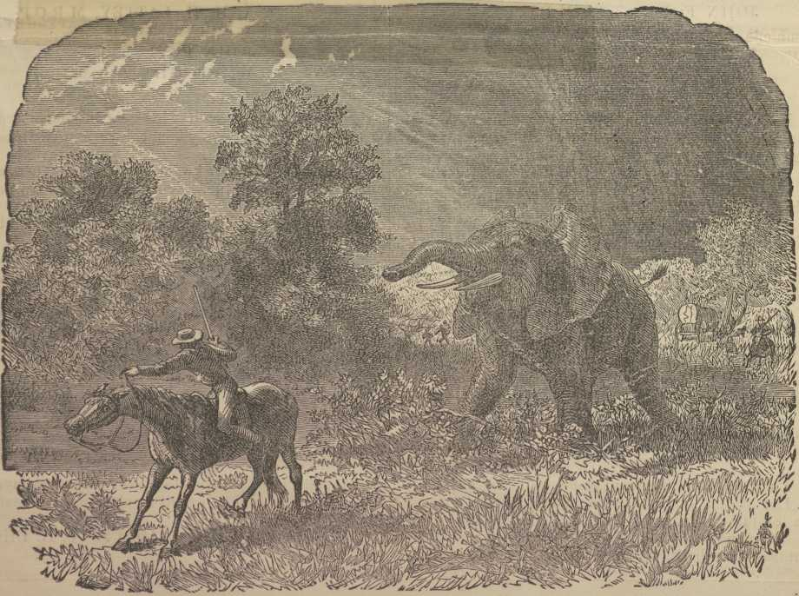
UKUDUTYULWA KWENDLOVU.

