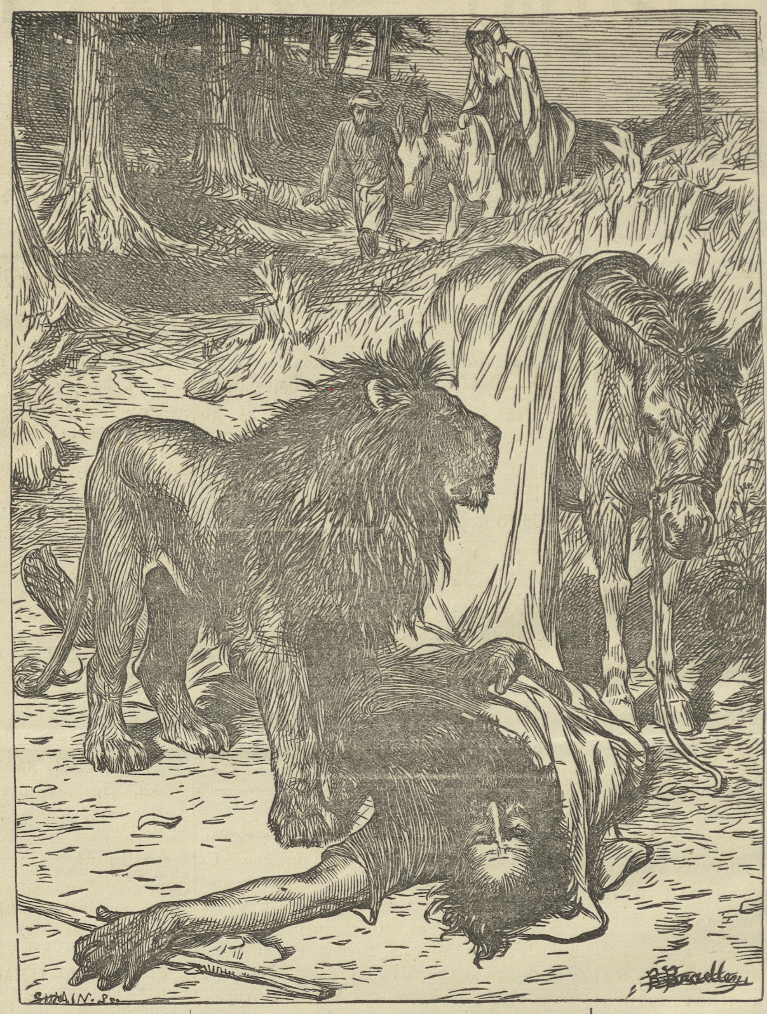
6 ISIGIDIMI SAMAXOSA, JANUARY 2, 1873.
umporofeti ONGEVAYO.
I. yokumkani xiii. 20-30. Mleseshi ! ngawo onke amaxesha kulilala kuko inkatazo, maxa wambi kubeko ukufa, kwabangayi pulapuliyo imiteto ka Tixo. Masinga pulapuli kuzo zonke izinto eziveliswa ngabantu, kodwa masicinge ngemiteto ka Tixo ngobulumko nenyameko. Kwinto zonke masingasi libali isipelo, nokuba Umgwebi wetu wokugqibela ngu Tixo.
“ Kwaza kwati, besahleli bona ngasesitebeni, leza ilizwi lika Yehova ku mporofeti obeyibuyisile; owabiza ngakuyo indoda ka Tixo eyavela kwa Juda, esiti: Utsho U- Yehova ukuti: Ngenxa yokuba uvukele umlomo ka Yehova, nokuba unga- gcinanga umyalelo abekuyalele wona U-Yehova, U-Tixo wako, koko ubu-ile, udlile isonka, use- lile namanzi, endaweni abete kuwe ngayo : Ungahli isonka, ungaseli na manzi; isidumba sako asiyi kuza encwabeni loyililo bako.
Kwaye kute, emveni kokuba ibidlile isonka, nasemveni kokuba ibise- le, wandula wabopa iqwa- rashe, ebopela umporofeti
owabembuyisile. Yasuka yahamba, yaza ingonyama yafumanana nayo endleleni, yayibulala: saye isidumba sayo siposiwe pantsi endleleni, lati inqwarashe lema ngakuso, nengonyama yema ngasesidunjini. Kekaloku bonake amadoda ebedlula, abona isidumba sipo- siwe pantsi endleleni, nengonyama imi ngasesidunjini ; ayesiza axelela esixekweni, apo umporofeti omdalaebehlala kona. Akuva umporofeti owayibuyigayo endleleni, wati: Yindoda ka Tixo, eyavukela umlomo ka Yehova ; ngako U-Yehova uyinikele engonyameni, eyapuleyo, yayibulala, nje- ngelizwi lika Yehova, elo walitetayo kuyo. Waza wateta konyana bake, esiti: Ndibopele iqwarashe. Babopa ke. Wa-suka wahamba, wafumana isidumba sayo sipose pantsi endleleni, kwa neqwarashe nengonyama zimi ngasesidunjini: ingonyama ibi ngadlanga isidumba ibi ngalapulanga iqwarashe kanjalo. Wandula umporofeti wa- funqula isidumba sendoda ka Tixo wasilalisa eqwarasheni, wabuya naso : waye umporofeti omdala esiza esixekweni, ukwenza isijwili, nokuyincwaba. Wayelalisa isidumba sayo kwelake incwaba; baza benza isU jwili pezu kwayo, besiti ; Au, mzalwana wami ”
IZINTO NGEZINTO.
Oee bunxila.—Umfo ontsundu ubulewe ku-kunxila E-Bayi.
Ikoton esand’ ukucokiswa ngomnye wabalimi bangase Bini ingapezulu kwe 100,000 lbs.
Baninzi abantu abalishiyayo ele Diamondi; kodwa bambalwa ngoku abayayo kona.
Iposi.—Abantu base Natal bazamela ukuba kubeko iposi esuka kwelilizwe iye kona iveki zonke.
Okatywe lihashe.—U-Mr. Waldeck ubulewe kukukatywa lihashe kwele Diamondi.
Ukuvulwa kwetyalike.—E-Bothas BushE- Katala kuko indlu yetyalike esand’ ukuvulwa. Intle yomelele.
Omiweyo.—Umfo ontsundu ubemiwe yinyama E-Bayi ngemini ye Kristmas, yapants’ ukumbulala.
Intengo.—E-Aberdeen ngomhla we 16 ka January kuyakutengiswa inqwelo entsha, igushakazi ezi 600, inkabi zegusha ezi 200, inkomo ezi 36, inkabi ezi 24. Kwangalomini E-Rini kuya kutengiswa inkabi ezi 16,
Obulewe yindoda.—E-Dikeni kuko umfazi we Lau obetwe yindoda wada wafa, imbetela ukuba ebenxilile. Ngoku isetolongweni.
Intengo.—E-Graff Reinet ngomhla we 10 ka January kuyakutengiswa inkabi ezi 60, nebokuva ezimbini.
Isilumkiso.—Umqubi otile wenqwelo udliwe isheleni ezisixenxe ezinepeni ezintandatu, E-Rini ngenxa yokuba inqwelo yake ibingenamkokeli.
Inciniba.—U-Mr. Thomas White wakufupi nase Rini usand’ukutenga inciniba ezisencinane zima 30, wazirolela iponti ezi £400.
Obepete ink abt kakubi.—E-Rini U-Hendrick Smith, Hau, kutiwe makarole ishumi lesheleni, ati ukuba akaliroli abe ntsuku zili 14 etolongweni, ngenxa yokuba esuke wayipata kakubi inkabi yenkosi yake.
President Brand.—Kuvakala ukuba akuseko temba lokuba U-President Brand, umpati we Free State, usaya kubuya apile. Ubeseletumele ukuba kuye kubizwa abantwana bake E-Kapa ukuze ake ababone pambi kokuba emke.
Imfegu etile ibulewe kukuwelwa yintsika E-Bayi.
Umlimi otile wase Natal usand’ ukufumana itea ekula kakuhle.
Kuko enye inqwelo yomlilo esand’ ukuziswa kwelilizwe ivela E-England.
Imali efike ngalomnyaka wodwa ivela kwama, nye amazwe ingapezulu kwe £1,000,000.
E-Free State, kuko ezinye inqwelo ezibe zitwele oziruluwa nemipu, ezisand’ ukubanjwa ngomteto we Government yakona.
I-Government entsha.—Lomadoda azakupa- ta Ikoloni ngoku, umsebenzi wawo awuqale ngomhla we 3 ka December.
Ukudlisa.—E-Richmond kuko intombi yomxo- sa esand’ ukufakwa etolongweni ngetyala lokuba- idlise U-Mrs. Russouw wase Hartebeest Fontein, ebihlala. kuye. Ngoku iselide yalivuma elotyala.
Pesheya kwe Nciba.—Kuvakala ukuba aku- kabiko konwaba kwelozwe. Sisalindele ukuva ku, madoda ayetunyiwe, ukuba avumelene ngadanwo zinina ngokumalunga no Rili no Ngangelizwe.

