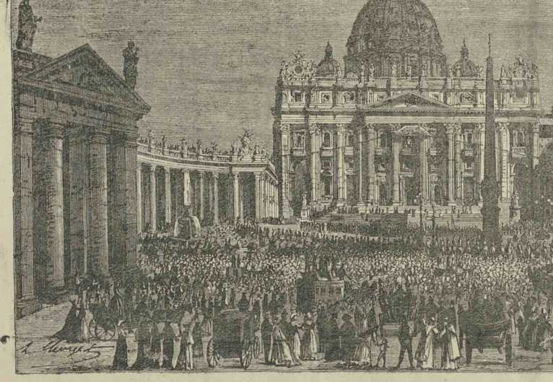
ITYALIKE EKUTIWA YI ST PETER'S E ROME
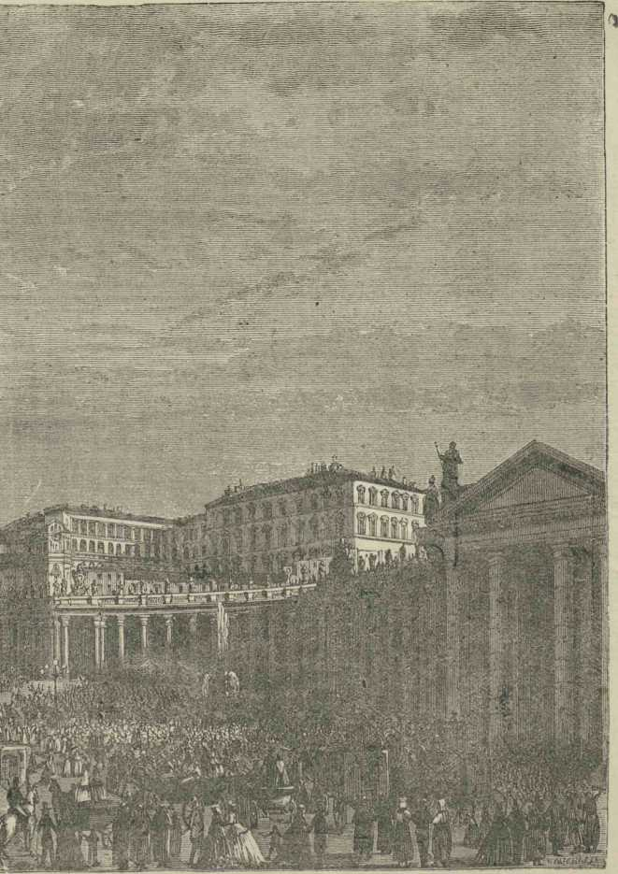

4 ISIGIDIMI SAMAXOSA, JANUARY 1, 1875

