"KUGQITYIWE.”
Key E Flat. [Words from Kaffir Hymn Book, No. 85.] John Knox Bokwe.
- “ Kugqityiwe ” ukuxelwa Ngaba porofiti Konke okwatenjiswayo Kuzalisekile.
- “ Kugqityiwe ” ukublaulwa Ngu Mlamleli emnye, Bagwetyelw’ abakolwayo, Ngeli lizwi linye.
- “ Kugqityiwe,” uxolile U Tixo wezulu;
Ubu tshaba bupelile
Ngobubele bake.
- “ Kugqityiwe ” masivuye, Sihambis’ indaba;
Sibabize baguquke
Abemi bomhlaba.
I GOVAN BURSARY.
KUYA ziswa ukuba kuya kubako i Bursary ezi mbini, eyoku qala zi £10, eyesi bini zi £5 ; zombini ke, zezo mnyaka omye. Ziya ku gqatselwa ngawo lo umnyaka.
Izimiso zezi:—
- I Bursary ezi, zivulelwe udodana Iwama bala onke, aba lukolo lulolwe Protestant, baze nange zinye indlela ba nyuleke.
- Aba Ngeni abaza ku viwa mababe sebe lu gqitile olu viwo loku ngeniswa, lwase Lovedale.
- Aba Ngeni maba vunywe kuqala yintlanganiso yaba Pati be Mali, na yi Education Board yase Lovedale.
- Aba Ngeni botumela ama gama abo ngepepa, kunye ne saziso sesi milo sabo esi kolekayo, ku Rev. J. D. Don, o gama libekwe apa, kungabi ngapantsi kwe nyanga, pambi kwe mini yo viwo.
- Uviwo luya kwenziwa ngoku bala ema pepeni; luya kuba se Lovedale nge veki yesi bini ka August, 1880.
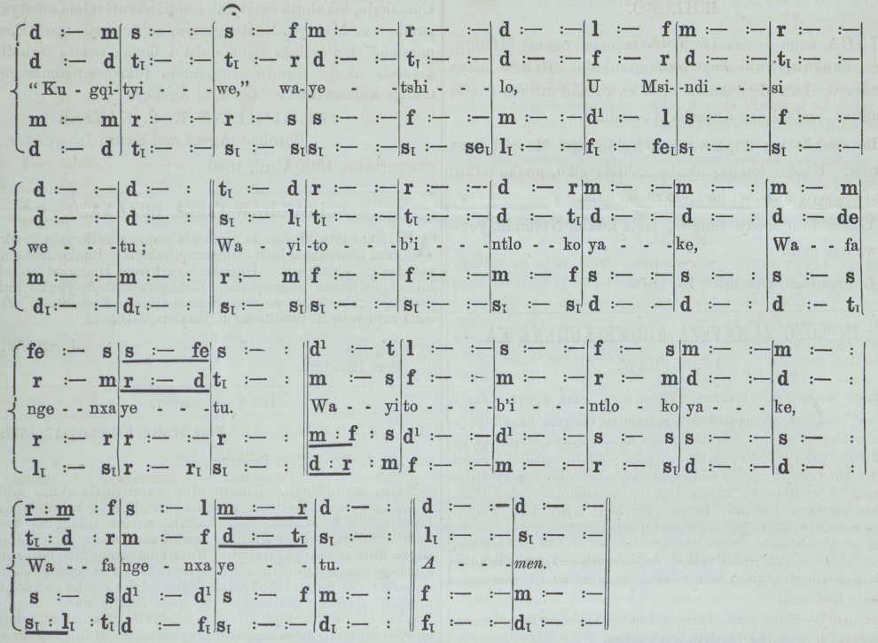

- Aba zifumeneyo i Bursary baya ku funda e Lovedale nge xa aba se nazo.
- Zinga blutwa ezi Bursary ngo ku swela isimilo ababa nazo. Aba gwebi balonto baya kuba, ngaba Gcini be Mali ne Education Board yase Lovedale.
Izinto zo Fiwo.
(1.) Izibalo, yi Compound Proportion, kunye ne Vulgar, ne Decimal Fractions.
(2.) Kwi English Grammar, ne Analysis.
(3.) Uku xela ngo kuma komhlaba (Descriptive Geography).
(4.) Imbali ye Great Britain, kususela kwi 1603 kude kuze kuba kweli xesha.
(5.) Ukuzazi izi Balo ; kweyo I. neye II. ka Samuel; ne Zenzo zaba Postile.
John D. Don,
President of the Board of Trustees.
King Williams Town, February 23, 1880.

