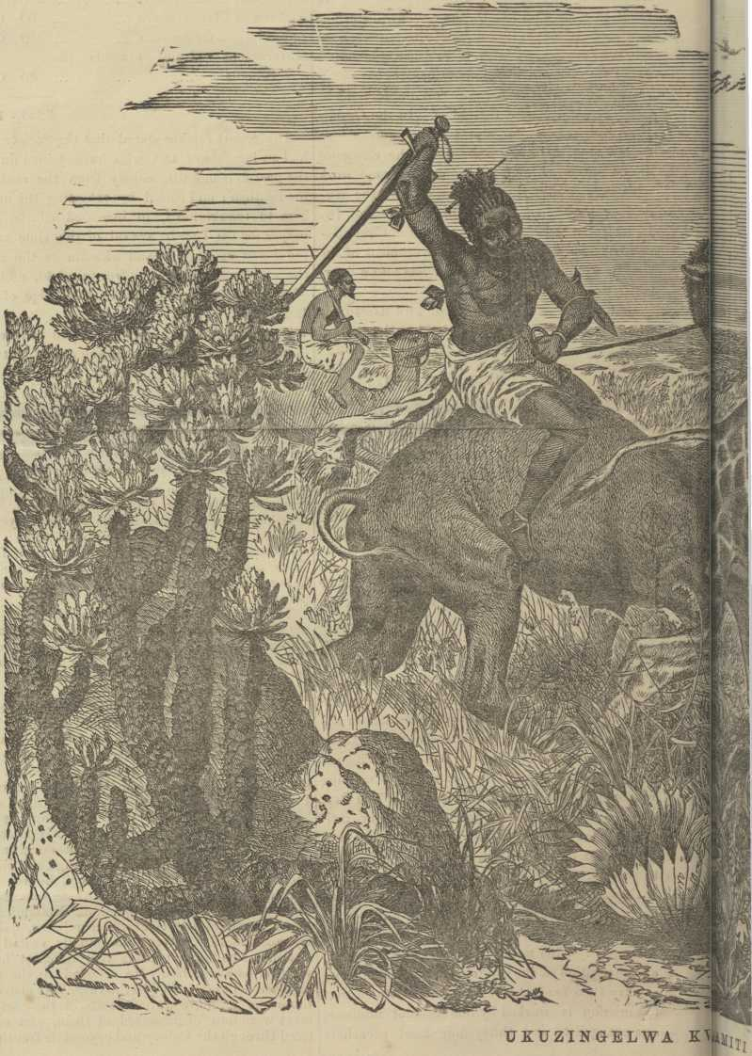
4
THE KAFFIR EXPRESS, SEPTEMBER 1, 1872.
TELEGRAPH OFFICE TEMPOR-
ARILY OPENED.
The following notice and telegram were published at Lovedale on the 10th of last month. Mr. Den’s visit to Lovedale was highly appreciated by both Europeans and Natives. On his leaving, the native pupils, apprentices, and students, assembled together. He addressed to them a few words ; Dr. Stewart thanked him for his visit, and for the friendly interest he had taken in the establishment of an office at Lovedale to be worked by native operators. Three hearty cheers were thrice given by the assembled natives for Mr. Den as he drove off to Fort Beaufort.
Saturday, August 10th.
The office at Lovedale was temporarily opened to-day by Mr. Den.
Congratulatory messages were sent to the Hon’ble Mr. Southey, and to other friends of the Institution, throughout the Colony.
FIRST TELEGRAMS
TO AND FROM
LOVEBALE.
FIRST MESSAGE SENT.
“ The Lovedale Institution thanks the Hon’ble Mr. Southey for the assistance rendered by Government in placing the district in telegraphic connection with the metropolis and other parts of South Africa.
“ May South Africa be speedily united to England by a cable ! ”
FIRST MESSAGE RECEIVED.
ALABAMA QUESTION SETTLED.
Cape Town, 10th August, 1872.
The R.M. St. Celt arrived in Table Bay yesterday.
Alabama question settled.
Australian wool reported firmer. Capes same.
Diamonds steady.
Syria arrived home on 2nd July. Himalaya, for this port, left 10th July; Gladys to leave in August. Bladsworth, to leave on 23rd July.
East London, 10th August.
Bismarck lying at jetty in river all right, with exception of loss of fan.
NOTICE.
Arrangements for the transmission of telegrams will be completed shortly, due notice of which will be given.
DEATH OF DR. ALFRED HOLDEN.
Died at Cape Town, unexpectedly, on the 26th Aug., Dr. Alfred Holden, medical officer of the R.M.St. Celt. Dr. Holden was a young practitioner of much promise and ability. He was the son of the Rev. W. C. Holden, Missionary at Middle Drift. Much sympathy is felt for his sorrowing parents. Some years ago Dr. Holden was a pupil in Lovedale Institution.
HEADS OF KAFFIR NEWS.
FISH RIVER BRIDGE COMPANY.—ILLUSTRATIONS : HUNTING SCENES IN AFRICA.—FOREIGN NEWS. —DEATH OF NOYI.—MISSIONARY MEETING.— NEWS FROM DIAMOND FIELDS, BASUTO LAND, AND NATAL. MISCELLANEOUS. — CORRESPON-
DENCE.—ADVERTISEMENTS, &C., &C.

