Isigidimi Sama-Xosa.

Vol, III. LOVEDALE, SOUTH AFRICA, MAY 1, 1873. No 32.

IMIFANEKISO.
Kwesi Sigidimi sinika imifanekiso enga- faniyo nangento. Omnye ubonisa apo umkombe ubambeke emkenceni elwandle- Akuko nto inokudlula leyo ngobubi, kanti noko ibako futi kwezo lwandle. Unxweme olungasentla lwase Asia, nase Europe, nase America, luhlala luzaliswe likepu.
Abantu balomazwe bambalwa, nezityalo ezihluma kona azibancedi nto. Sebesiti ke ngoko bapile zintlanzi. Ulwandle olungasentla kwalamazwe luzele zizo. Kuti kwezinye indawo zolo Iwandle umkence ude ube ngangenduli. Ziko iziqiti kodwa zibanda kangangokuba kungabi nakuhlala mntu. Enye into abati bapile yiyo ababantu sisilo ekutiwa yi Seal. Sidla intlanzi sikolise ukuhlala emanzini, noko simana ukuza kuvela ngapandle ukwenzela ukuba sipefumle. Kanjalo silala emkenceni.
Bati abasizingelayo balinde xa sizakuti tu basihlabe. Ati amafuta aso abaswe ize inyama idliwe. Esinye isilo esidliwayo yi Bear emhlope. Ngamanye amaxesba iya ifunyanwe pakati elwandle emkenceni odadayo. Noko ikwaziyo kakuhle ukudada, ayinakuhlala xesha lide emanzini. Yinto enqabileyo kanye kwelozwe kuba isikumba sayo kwenziwa ingubo ngaso.
Angade ke umntu acinge ukuti bahleli kubi abantu balapo, kanti noko ungafika bonwabile. Into enkulu abafuna yona

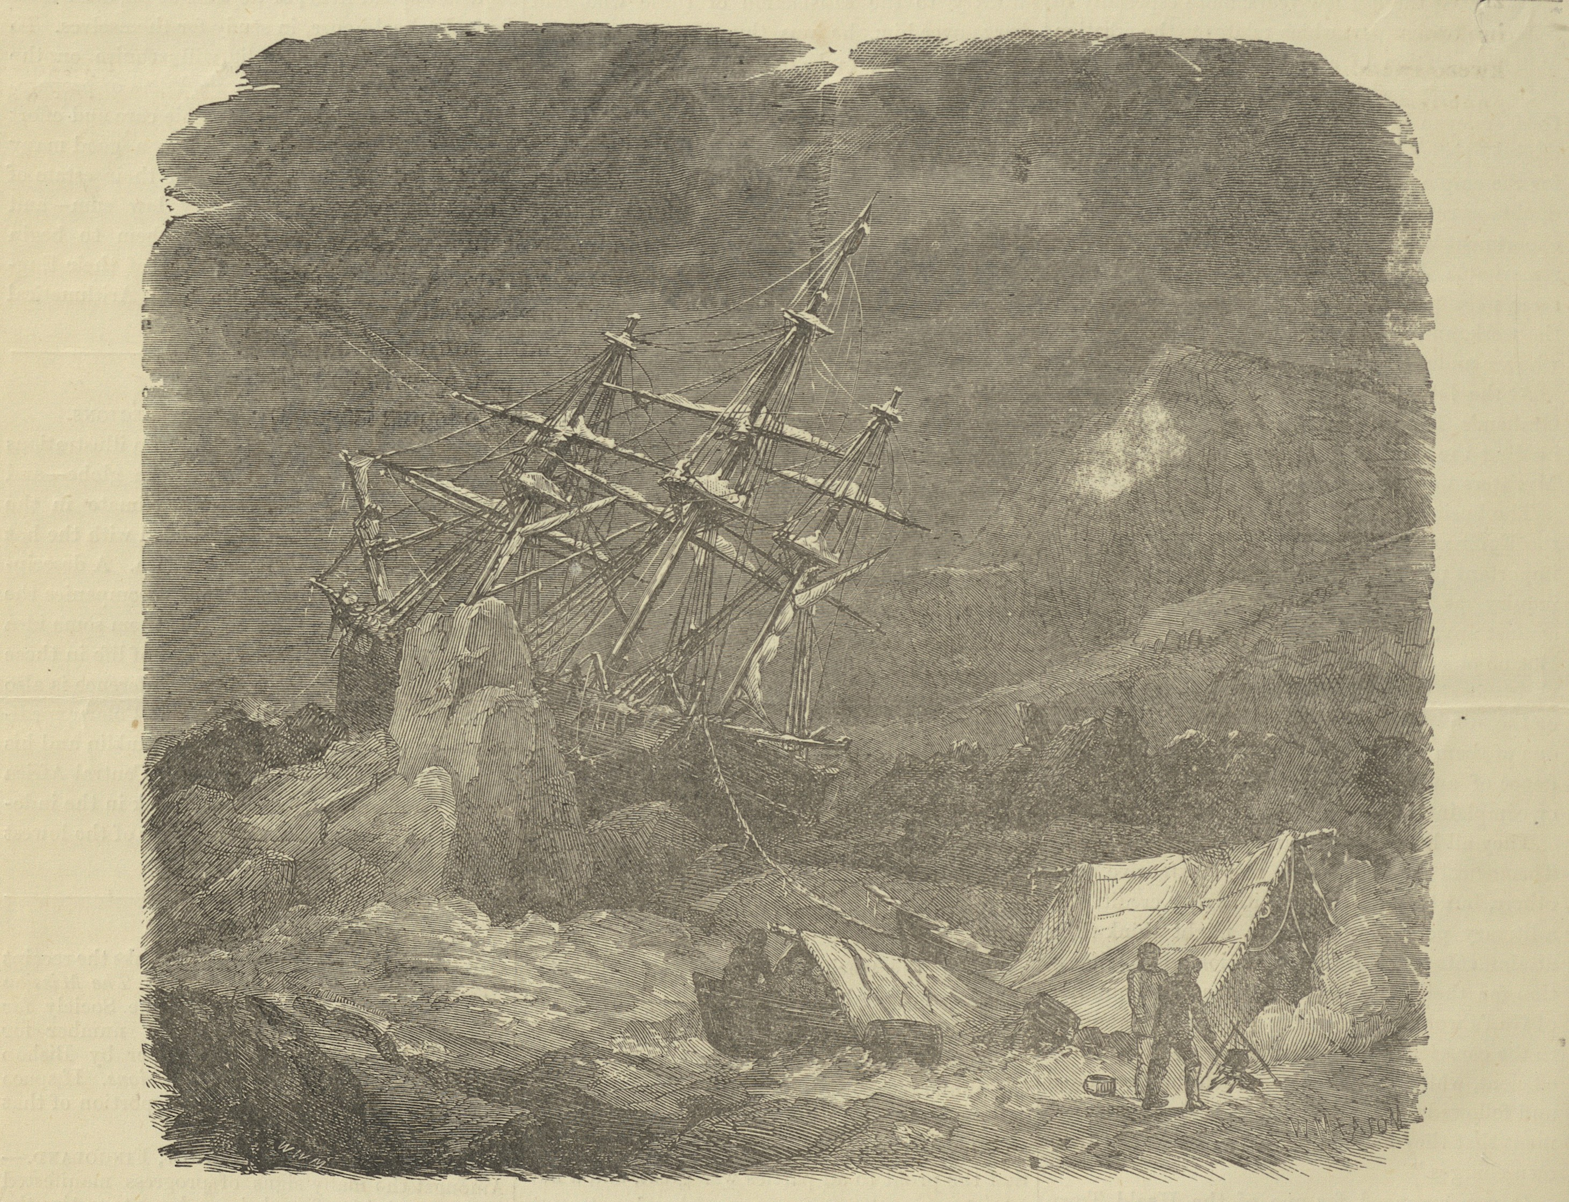

UMKOMBE OBAMBEKE EMKENCENI

Isigidimi Samaxosa

