ISIGIDIMI SAMAX0SA, JULY 1, 1880. 7
3. Yimini abantu be Nkosi baqela
Ukuva indaba zovuyo:
Yimin’ amakolwa alangazelela
Indawo asinga ngakuyo.
Key B5. IMINI YE NKOSI.
Joyfully. [Words from Kafir Kymn Book, No. 179.] J. Knox Bokwe.
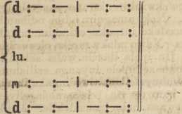

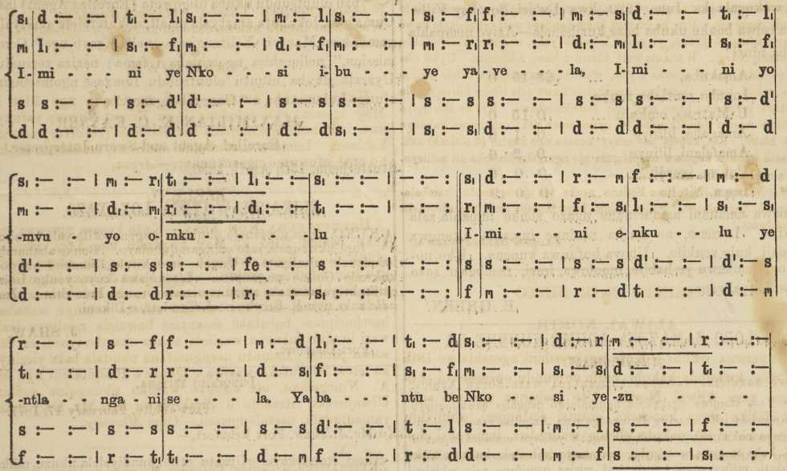

2. Yimini yapumla i Nkosi yezulii
Ukwenza izulu no mhlaba;
Yimini wesuk’ u Mkululi omkulu Wapuma kwe lake incwaba.

4. Vuyani, Makolwa! Vuyani Makristu! Nizuke i Nkosi enkulu;
Nobehle kwi zinto ezi dinisayo, Nipumle kwa nani pezulu.

I GOVAN BURSARY.
KUYA ziswa ukuba kuya kubako i Bursary ezi mbini, eyoku qala zi £10, eyesi bini zi £5 ; zombini ke, zezo mnyaka omye. Ziya ku gqatselwa ugawo lo umnyaka.
Izimiso zezi:—
- I Bursary ezi, zivulelwe udodana Iwama bala ouke, aba lukolo lulolwe Protestant, baze nange zinye indlela ba nyuleke.
- Aba Ngeni abaza ku viwa mababe sebe lu gqitile olu viwo loku ngeniswa, Iwase Lovedale.
- Aba Ngeni maba vunywe kuqala yintlanganiso yaba Pati be Mali, na yi Education Board yase Lovedale.
- Aba Ngeni botumela ama gama abo ngepepa, kunye ne saziso sesi milo sabo esi kolekayo, ku Bev. J. D. Don, o gama libekwe apa, kungabi ngapantsi kwe nyanga, pambi kwe mini yo viwo.
- Uviwo luya kwenziwa ngoku bala ema pepeni; luya kuba se Lovedale nge veki yesi bini ka August, 1880.
- Aba zifumeneyo i Bursary baya ku funda e Lovedale nge xa aba se nazo.

- Zinga hlutwa ezi Bursary ngo ku swela isimilo aba ba nazo. Aba gwebi balonto baya kuba, ngaba Gcini be Mali ne Education Board yase Lovedale.
Izinto zo Viwo. i
(I.) Izibalo, yi Compound Proportion, kunye ne Vulgar, ne Decimal Fractions.
(2.) Kwi English Grammar, ne Analysis.
(3.) Uku xela ngo kuma komhlaba (Descriptive Geography).
(4.) Imbali ye Great Britain, kususela kwi 1603 kude kuze kuba kweli xesha.
(5.) Ukuzazi izi Balo ; kweyo I. neye II. ka Samuel; ne Zenzo zaba Postile.
John D. Don, President of the Board of Trustees.
King Williams Town, February 23, 1880.
UMHLABA OTENGISAYO.
KUKO umhlaba e-Debe otengisayo. Ubukulu bawo buzi akire eziliwaka eli nama kulu osi xenxe. Ofuna ukuva ngawo, nokuba linani lawo, nokuba kukuma kwawo, angaziva ezondawo ku Dr. Stewart, e-Lovedale.

