ISIGIMMI SAMAXOSA, NOVEMBER 1, 1872.
7

UMHLWAYELI.
Mateyu xiii. 3-9, ne 18-23,
“ Bona ke, umlilwayeli wapuma uku-
ya kuhlwayela; nasekuhlwayeleni kwa-
ke, ezinye inkozo zawa ngasendleleni,
zati intaka zeza zazidla. Zawa nezinye
endaweni ebulwalwa, apo bezingenawo
umhlaba omninzi; zaza zasezipuma
kamsinya ngokuba zingenabo ubunzulu
bomhlaba : zati nxa ilanga belipumile,
zatshiswa; nangokuba zingenangcambo,
zabuna. Zawa nezinye endaweni ye-
mitolo; yaza imitolo yahluma, yazi-
ntshwencisa. Zawa nezinye emhlabeni
olungileyo, zanika isiqamo ke, olunye
ngekulu, nolunye, ngamashumi mata-
ndatu, nolnnnye ngamashumi matatu.
Onendlebe zokuva, makeve.
“ Nina ngoko yivani umzekeliso wo-
mhlwayeli: Nxa sukuba umntu esiva
ilizwi lobukumkani, engaqondi ke, uyeza
okohlakeleyo ahlute oko kuhlwayelweyo
entliziyweni yake: ngnye lo owaye-
hlwayelwa ngasedleleni. Nowayehlwa-
yelwa endaweni ebulwalwa, nguye lo
oti ilizwi alive, asuke alamkele ngovuyo;
koko engenangcambo pakati kwake,
uyenza umzuzu kodwa; kuze kuti,
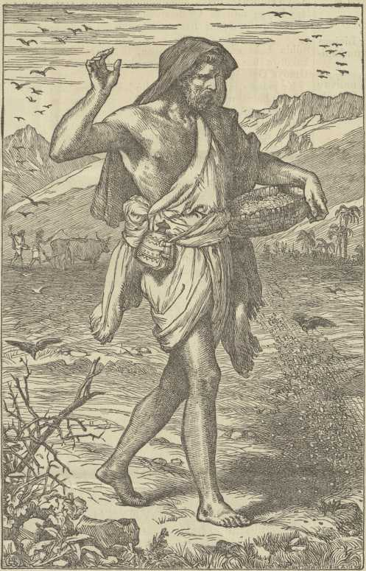
kwakuhla imbandezelo umhlaumbi intshutshiso ngenxa yelizwi, asuke axa- kaniswe. Nowayehlwayelwa endaweni yemitolo, nguye lo oti ilizwi alive; kanti isitukutezi selilizwe likoyo, nenkohliso yobutyebi, ziyabulala ilizwi, lize liputiswe. Nowayehlwayela emhlabeni olungileyo, nguye lo oti ilizwi alive, aliqonde; oti kanjalo axakate izixakato, enze omnye ngokulikulu, nomnye ngokungamashumi matandatu, nomnye ngokungamashumi matatu.”
Wena mleseshi! ukuba uke waliva ilizwi lika Tixo lishunyayelwa mayibe ke lembewu inqabileyo ike yahlwayelwa entliziyweni yako. Ivelise ziqamo zini na kuwe? Ingaba ihlwayelwe endle- leni na yacolwa zintaka zezulu ? Site isiqamo sayo saba kukuyivuma okwexe- shana elifutshane kwakupela na ? Ate na ameva abukali asemhlabeni ayintshwencisa? Nokuba ite na yavelisa isiqamo esifezekileyo, esiyakuba litamsanqa ebantwini, sibe ludumo luka Tixo? Lombuzo wupendule ngok nyanisekileyo ngokuba empilweni yako iko imini ate “ umhlwayeli wapuma ukuya kuhlwayela ” entliziyweni yako !
IZINTO NGEZINTO.
Ibandla ekutiwa yi Dutch Reformed Church litumele umfundisi kuma Koranna ase Gqili.
Indlala.—Sinosizi ukuva ukuba indlala ingene Emampondweni. Kutiwa abanye sebepila kuku- dla ingcambu zemiti. Kuko oseleke wabulawa yiyo,
Kwelika Adam Koko kutiwa ukudla kunqabe kangangokude inxowa yombona idle £2. Na- kwelama Zulu kutiwa abantu bayapala ukufuna ukudla.
Ama Portuguese akavumi ukuba ukudla okuse- zweni elipantsi kwawo kutengiswe kwamanye amazwe.
E-Natal kuzakwenziwa indlela yenqwelo zom- iizo ende kakulu.
Isifo Segusha.—Abafuyi abatile bangase Aliwal North, balablekelwe yinto eninzi yegusha, zibulawa sisifo esitsha, esizibamba ngemipunga nangesibindi.
Kuko umbo osand’ ukububa E-Mossel Bay, ubudala bake buyi minyaka emashumi osibozo ana mihlanu. Ebuncinaneni bake wake walikoboka. Usapo lwake, (xa sekudityaniswa nabazukudwana) luli 119. Umfazi wake uminyaka ilishu- nli ngapezu kwake.
abafuyi BASE Sidbuby basand’ ukuba nentla- nganiso. Bafuna indlela zokuzuza izicaka elu Sutu, nge 10s. ngenyanga.
Obe kukunxila—E-Bayi kuko umfo ontsundu osand’ ukufunyanwa efile ebulewe butywala.
Umongameli we Transvaal Republic U-Burgers usatyelele kule Koloni. Kwindawo aseleke waziya wamkelwe ngobubele obukulu.
Ingqele kutiwa ibininzi kanye ngase Graaff' Reinet. Ite intombazana ebiyekuteza yafela endle ngenxa yayo.
Abesutu kubonakala ukuba bayahluma kanye ngoku bepantsi kwama Ngesi. Abanye sebenemi- hlambi yegusha, abanye bakolise ngemali.
Inyamakazi.—Kutiwa amabadi ayabugqiba utyani E-Graaff-Reinet nase Richmond. Ayimi- hlambi emikulu evela kumazwe angasentla. Abo- nakala ukungati agxotwe lilanga nokusweleka kwenca. Umteto awuvumeli ukuba adutyulwe ngelixesha lomnyaka. Abalimi bezondawo baya- kala, bati ayawagqiba amasimi abo.
Amalahle la ambiwayo asand’ ukufunyanwa E-Bathurst na kuba kodwa kungeka qondakali ukuba maninzina.
Obulele Umntwana—E-Free State kuko umntu osand’ ukubulala umntwana. Ute akufa- kwa etolongweni walinga ukuzibulala ngokwake.
Umongameli we Free State, U-Brand, uni- kwe inyanga ezintandatu zokuba apumle emsebe- nzini ngenxa yokuba engapile kakuhle. Kumiswe imini etile yokumtandazela ukuba apile.
Inqwelwana Zomlilo—Kuko enye yezinqwe- Iwana esand’ ukuvela pesheya, iziswa yindoda yale Koloni. Kangangoko ike yalingwa ihamba kakuhle. lyakuba kulendlela ipakati kwe Wellington ne Worcester.
Obulewe Kusiliwa.—Kute E-Somerset East kwalwa Amaxosa amabini ngeziveki zesand’ uku- dlula, omnye epete induku, omnye enamatye. Uteke obenenduku wabulawa. Ngoku lowo ube- namatye usetolongweni.
Indlela Yenqwelo Zomlilo esuka E-Monti isiya E-Q,ueenstown kusakangelwa apo ingaflka icande kona.
Onyatelwe Yinqwelo. — Ute umbexeshi ontsundu evela E-Uitenhage nenqwelo, wawa kuyo xa angase Graaff-Reinet, yati imilenze emi- bini yamnyatela entloko yayityumza, wafa kwa oko.
Imfuduko.—Kuvakala ukuba into eninzi yaba- fuyi balapa iza kufudukela E-Transvaal Republic.
Inkumbi zisezingene kwinxenye yamazwe anga- sentla. Njengokuba linjenje nelanga ingankulu intshabalalo ukuba zike zaninzi kakulu.
Ikofu.—Emarkeni yase Qonce bekuko ikofu ebize kutengiswa kona, ibilinywe ngase Monti. Ingumqondiso omhle obonisa ukuba kanti ikofu ingalinywa nakweli lizwe.

